Attention in use of Windows Vista

Because the Security of Windows Vista has been reinforce compared to Windows 2000/XP, there are some different points in operation
Please follow below attentions in use of TSP700II software with Windows Vista.

[Installation]
a. Execute Installer
TSP700II Installer can not be executed by just only inserting CD into Vista PC.
Please refer to following procedure to execute installer.

1. Insert TSP700II CD into Vista PC.

2. Click [Run Autorun.exe]
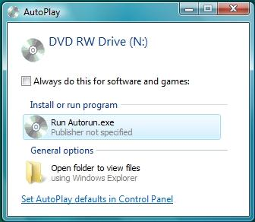

3. Click [Continue] or [Allow] when the [User Account Control] screen appears.

Then you can execute installer.

b. Warning message while installation
Select [Install this driver software anyway] when following message appears.
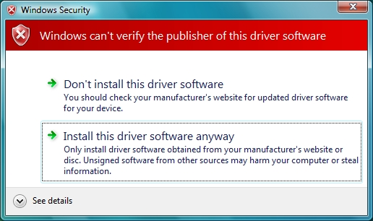

[TSP700II Configuration utility]
To use TSP700II Configuration utility, please refer to followings.

a. Execute from printer driver
1. Select Printer in Control Panel at Start menu

2. Right click “Star TSP700II printer” icon, select “Run as administrator”, and then click
“Properties”
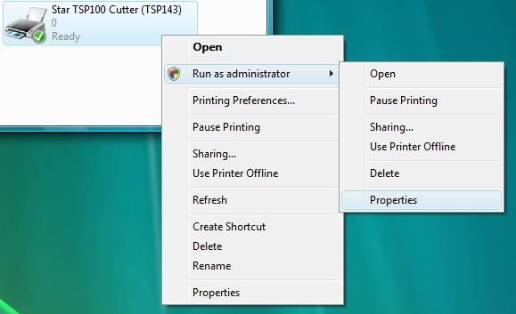

3. Click [Continue] or [Allow] when the [User Account Control] screen appears.

4. Execute Configuration utility in [TSP700II Config] tab.

Then you can execute TSP700II Configuration utility from printer driver.

b. Execute from Start Menu
1. Select [All Programs] in start menu, select “StarMicronics”, select “TSP700II”, right click
[TSP700II Configuration Utility], and then click [Run as administrator]
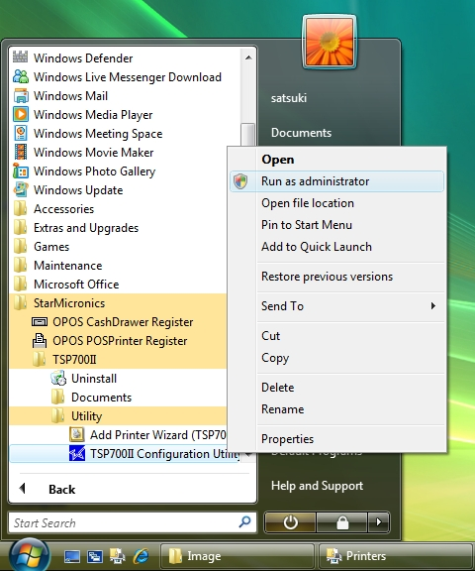

2. Click [Continue] or [Allow] when the [User Account Control] screen appears.

Then you can execute TSP700II Configuration Utility from Start Menu.

Note: It is possible to execute TSP700II Configuration Utility not selecting [Run as administrator], but TSP700II Configuration Utility can not work correctly. Please follow above manner to execute TSP700II Configuration Utility correctly.

[Uninstall]
Follow the instruction below when uninstall TSP700II software.

a. Start of Uninstaller
1 Select [All Programs] in start menu, select “StarMicronics”, select “TSP700II”, right click [uninstall], and then click [Run as administrator]

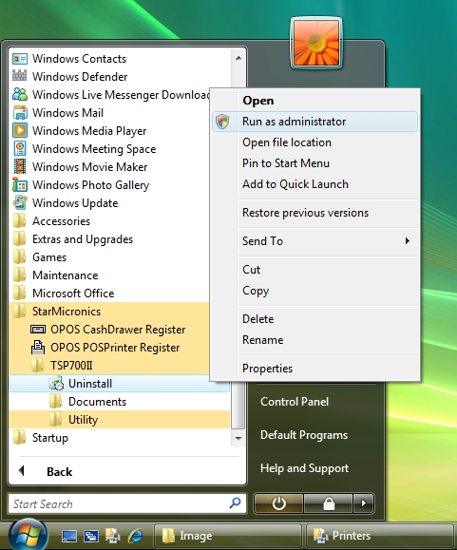

2. Crick [Continue] or [Allow] on [User Account Control] Dialog.

Then, uninstaller of TSP700II software starts.

b. Delete Star Virtual Port Emulator Device
“Star Virtual Port Emulator Device” cannot be deleted even if uninstaller of TSP700II software is executed.
To delete Star Virtual Port Emulator Device, please follow below instructions.

1. Double click [Control Panel] in start menu, double click [Administrative Tools], double click
[Computer Management]

2. Select [Device Manager] from [Computer Management] and right crick [Star Micronics
Virtual Port Emulator Device] in the device list, and then select “Uninstall”.
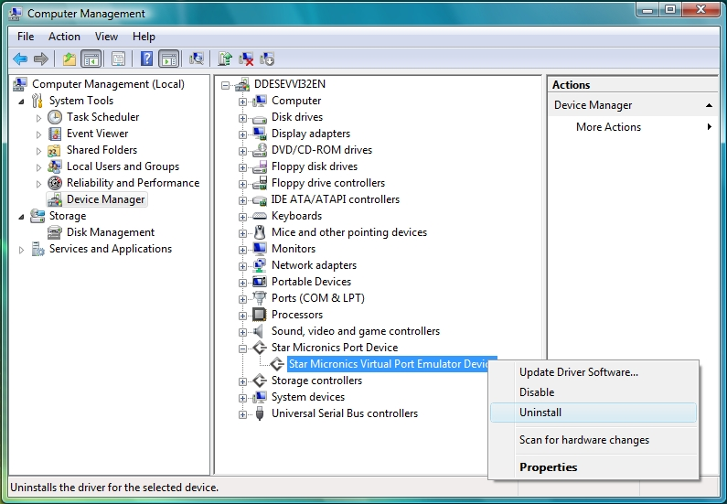

3. Check [Delete the driver software for this device] and crick “OK”.
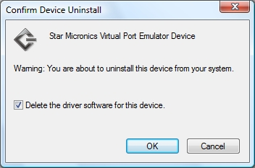

Delete of Star Virtual Port Emulator Device is completed.

